5.18: The maximum net force on the glider combination is
so the maximum acceleration is 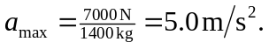
a) In terms of the runway length L and takoff speed 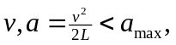 so
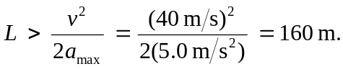
b) If the gliders are accelerating at 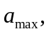 from Note that this is exactly half of the maximum tension in the towrope between the plane and the first glider.

